Nice Ride car sales report
Task 2.2 working template. Replace bracketed prompts before submitting.

Introduction
[State the manager’s question and explain that the report compares the six supplied fictional car-sales counts.]

Sales by brand
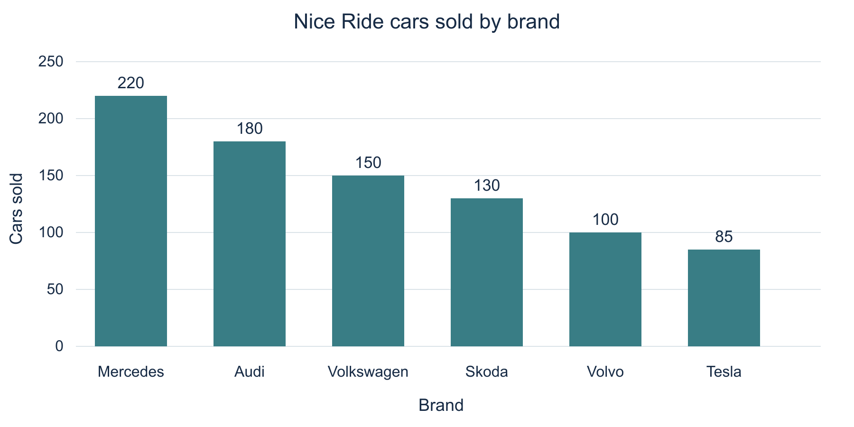
Figure 1 Cars sold by brand in the supplied Nice Ride data
[Write a short comment here. Identify the leading brand and its count, compare it with another brand, and explain the scope of the finding.]

Conclusion
[Answer the manager’s question. Do not infer causes, profit, dates or individual shop results from these totals.]

Data source
Noroff Analysis Reporting Task 2.2. Fictional Nice Ride data.
https://learning.noroff.no/mod/book/view.php?id=22937&chapterid=81727

